MATERIAL COMPONENTS

TEMA 1

* Autor: Alberto Velázquez Rapado
* Asignatura: Diseño de Interfaces
* Curso: 2º DAW

Contenido

App bars: top 5

Usage 5

Principles 5

Types 5

Anatomy 6

Banners 8

Usage 8

Principles 8

Types 8

Anatomy 8

Buttons 10

Usage 10

Principles 10

Types 10

Anatomy 12

Buttons: floating action button 13

Usage 13

Principles 13

Types 14

Anatomy 14

Cards 15

Usage 15

Principles 15

Types 15

Anatomy 15

Checkboxes 17

Usage 17

Principles 17

Types 17

Anatomy 18

Chips 19

Usage 19

Principles 19

Types 19

Anatomy 21

Data Tables 23

Usage 23

Principles 23

Types 23

Anatomy 24

Dialogs 25

Usage 25

Principles 25

Types 25

Anatomy 27

Image Lists 29

Usage 29

Principles 29

Types 29

Anatomy 31

Lists 32

Usage 32

Principles 32

Types 32

Anatomy 34

Menus 35

Usage 35

Principles 35

Types 35

Anatomy 36

Text list 36

Text and icon list 37

Text, icon, and keyboard command list 37

Text with selection state list 38

Nagivation drawer 40

Usage 40

Principles 40

Types 41

Anatomy 43

Progress Indicators 44

Usage 44

Principles 44

Types 44

Anatomy 45

Radio Buttons 46

Usage 46

Principles 46

Types 46

Anatomy 46

Sliders 47

Usage 47

Principles 47

Types 47

Anatomy 48

Snackbars 50

Usage 50

Principles 50

Types 50

Anatomy 50

Switches 52

Usage 52

Principles 52

Types 52

Anatomy 52

Tabs 53

Usage 53

Principles 53

Types 53

Anatomy 54

Text fields 55

Usage 55

Principles 55

Types 55

Anatomy 56

Tooltips 58

Usage 58

Principles 58

Types 58

Anatomy 58

# App bars: top

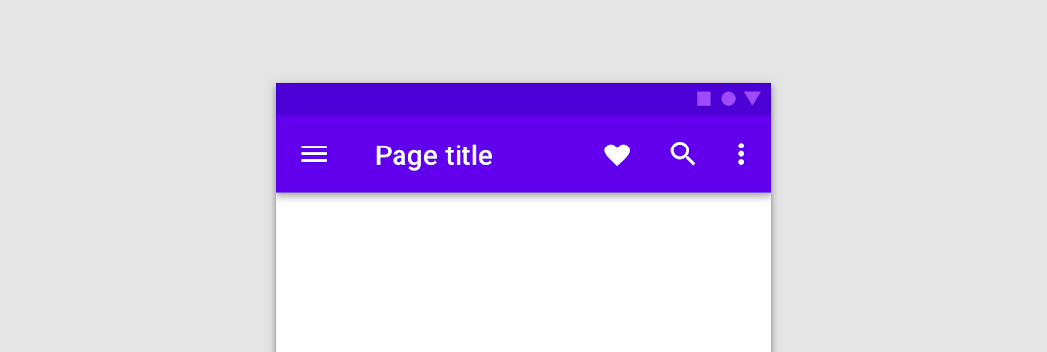

## Usage

The top app bar provides content and actions related to the current screen. It’s used for branding, screen titles, navigation, and actions.

It can transform into a contextual action bar.

## Principles

*Persistent*

Top app bars appear at the top of each screen in an app, and can disappear upon scroll.

*Guiding*

Top app bars provide a reliable way to guide users through an app.

*Consistent*

Top app bars have a consistent position and content to increase familiarity.

## Types

*Type 1: Regular*

A regular top app bar

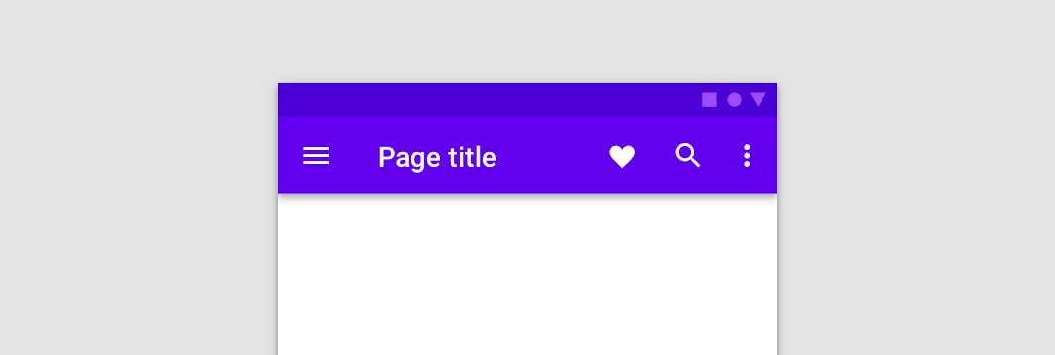

*Type 2: Contextual action bar*

Contextual action bars provide actions for selected items. A top app bar can transform into a contextual action bar, remaining active until an action is taken or it is dismissed.

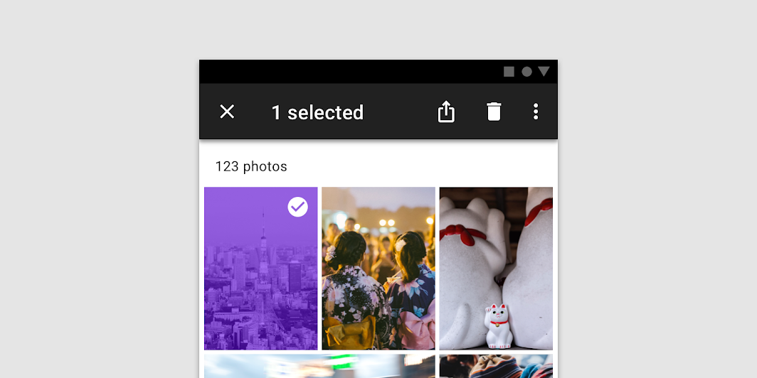

## Anatomy

1. Container
2. Navigation icon (optional)
3. Title (optional)
4. Action items (optional)
5. Overflow menu (optional)

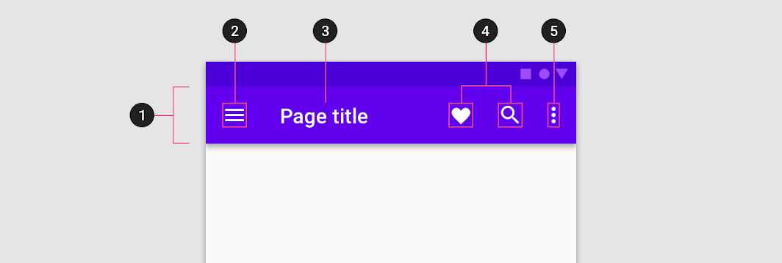

# Banners

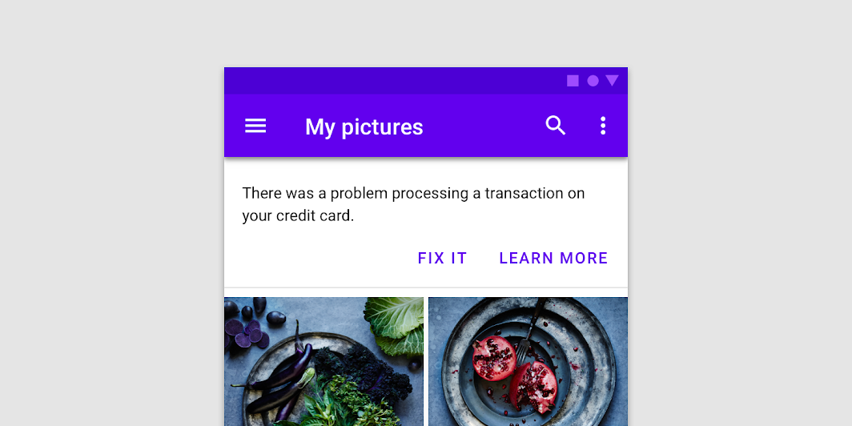

## Usage

A banner displays an important, succinct message, and provides actions for users to address (or dismiss the banner). It requires a user action to be dismissed.

Banners should be displayed at the top of the screen, below a top app bar. They’re persistent and nonmodal, allowing the user to either ignore them or interact with them at any time. Only one banner should be shown at a time.

## Principles

#### Appropriately interruptive

Banners are interruptive, but their level of interruption should match the information they contain and the context in which they appear.

#### Clear

Banners communicate a succinct message and what will happen if users interact with them.

#### Focused

Banners contain a single message and specific actions a user can take.

## Types

No Types

## Anatomy

1. Supporting illustration (optional)
2. Container
3. Text
4. Buttons

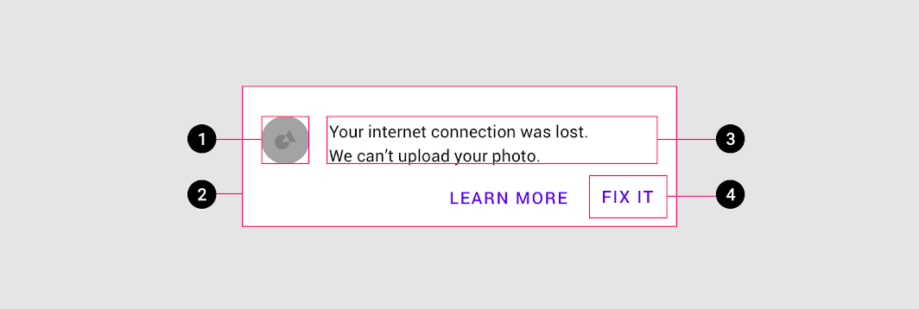

# Buttons

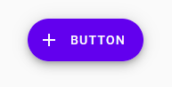

## Usage

Buttons communicate actions that users can take. They are typically placed throughout your UI, in places like:

* Dialogs
* Modal windows
* Forms
* Cards
* Toolbars

## Principles

#### Identifiable

Buttons should indicate that they can trigger an action

#### Findable

Buttons should be easy to find among other elements, including other buttons.

#### Clear

A button’s action and state should be clear.

## Types

**Type 1. Text button** (low emphasis)  
Text buttons are typically used for less important actions.

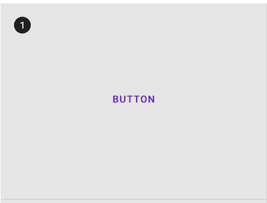  
  
**Type 2. Outlined Button** (medium emphasis)  
Outlined buttons are used for more emphasis than text buttons due to the stroke.

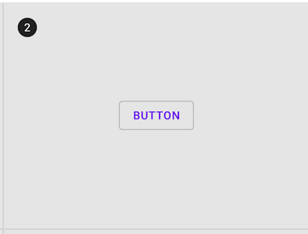  
  
**Type 3. Contained button** (high emphasis)  
Contained buttons have more emphasis, as they use a color fill and shadow.

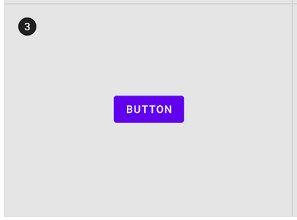  
  
**Type 4. Toggle button**  
Toggle buttons group a set of actions using layout and spacing. They’re used less often than other button types

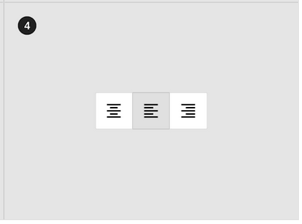

## Anatomy

1. **Text button**

A. Text label  
C. Icon (optional)  
  
**2. Outlined button**  
A. Text label  
B. Container  
C. Icon (optional)  
  
**3. Contained button**  
A. Text label  
B. Container  
C. Icon (optional)  
  
**4. Toggle button**  
A. Text label  
C. Icon (optional

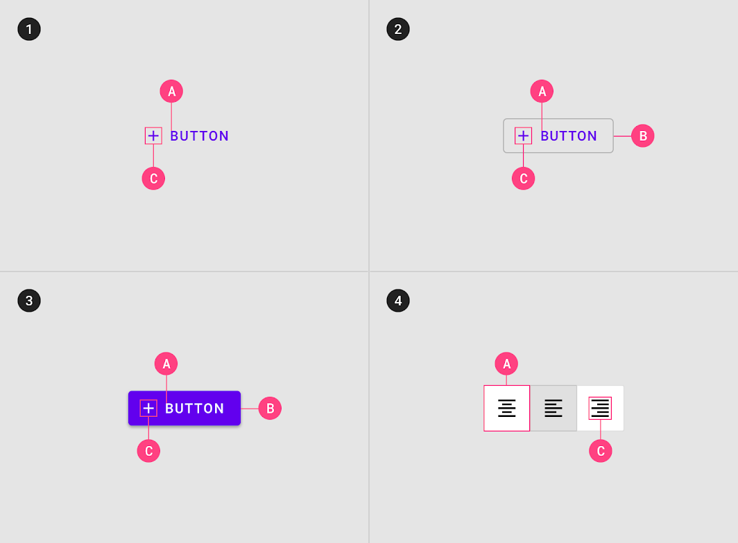

# Buttons: floating action button

## Usage

A floating action button (FAB) performs the primary, or most common, action on a screen. It appears in front of all screen content, typically as a circular shape with an icon in its center. FABs come in three types: regular, mini, and extended.

Only use a FAB if it is the most suitable way to present a screen's primary action.

## Principles

#### Primary

A FAB represents the primary action on a screen.

#### Constructive

A FAB should perform a constructive action (such as create, share, or explore).

#### Contextual

A FAB should be relevant to the screen on which it appears.

## Types

No Types

## Anatomy

1. Container  
2. Icon



# Cards

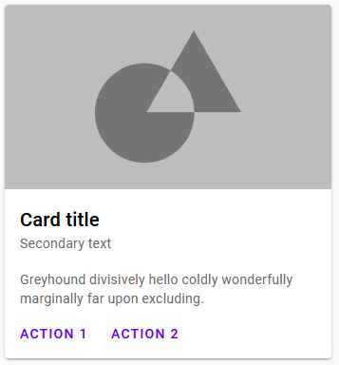

## Usage

Cards are surfaces that display content and actions on a single topic.

They should be easy to scan for relevant and actionable information. Elements, like text and images, should be placed on them in a way that clearly indicates hierarchy.

## Principles

#### Contained

A card is identifiable as a single, contained unit.

#### Independent

A card can stand alone, without relying on surrounding elements for context.

#### Individual

A card cannot merge with another card, or divide into multiple cards.

## Types

No types

## Anatomy

1. **Container**  
   Card containers hold all card elements, and their size is determined by the space those elements occupy. Card elevation is expressed by the container.  
     
   **2. Thumbnail [optional]**  
   Cards can include thumbnails to display an avatar, logo, or icon.  
     
   **3. Header text [optional]**  
   Header text can include things like the name of a photo album or article.  
     
   **4. Subhead [optional]**  
   Subhead text can include text elements such as an article byline or a tagged location.  
     
   **5. Media [optional]**  
   Cards can include a variety of media, including photos, and graphics, such as weather icons.  
     
   **6. Supporting text [optional]**  
   Supporting text include text like an article summary or a restaurant description.  
     
   **7. Buttons [optional]**  
   Cards can include buttons for actions.  
     
   **8. Icons [optional]**  
   Cards can include icons for actions.

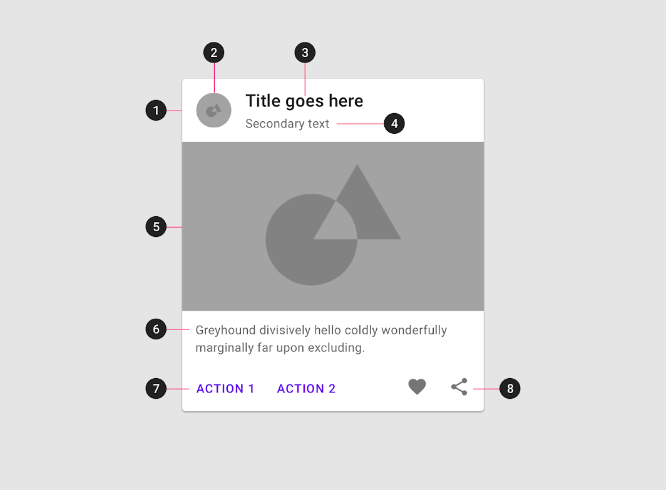

# Checkboxes

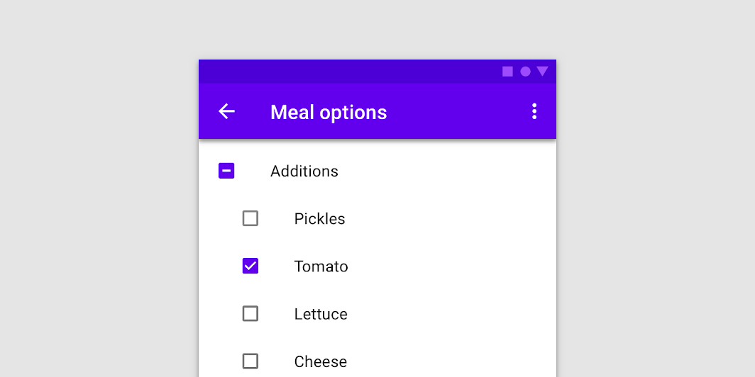

## Usage

Use checkboxes to:

* Select one or more options from a list
* Present a list containing sub-selections
* Turn an item on or off in a desktop environment

## Principles

#### Familiar

Checkboxes have been in user interfaces for a long time and should be used as expected.

#### Scannable

It should be visible at a glance if a checkbox has been selected, and selected items should be more visually prominent than unselected items.

#### Efficient

Checkboxes make it easy to compare available options.

## Types

Type 1: Checkboxes

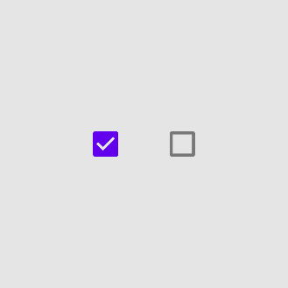

Type 2: Radio buttons



Type 3: Switches

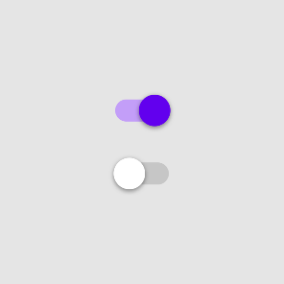

## Anatomy

No Anatomy

# Chips

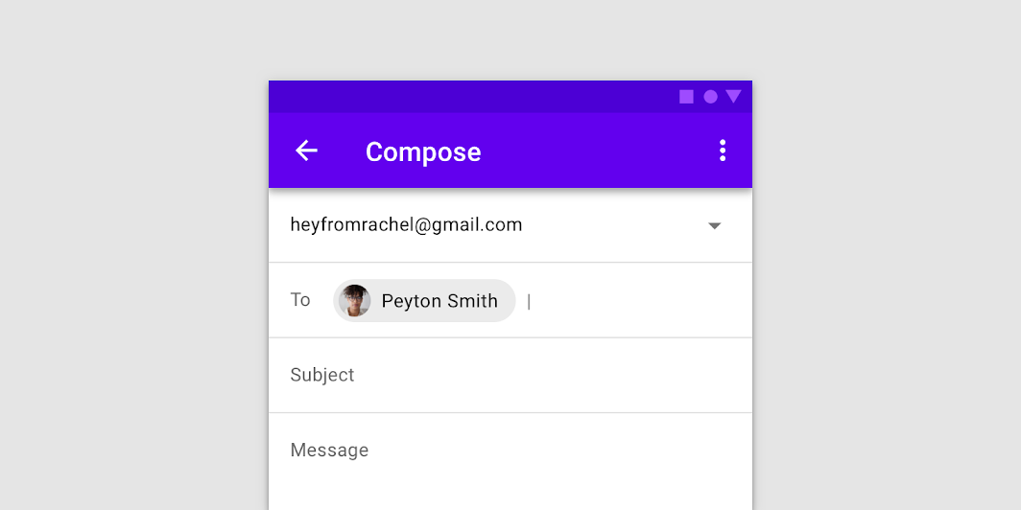

## Usage

Chips allow users to enter information, make selections, filter content, or trigger actions. While buttons are expected to appear consistently and with familiar calls to action, chips should appear dynamically as a group of multiple interactive elements.

## Principles

#### Compact

Chips are compact components that represent discrete information.

#### Relevant

Chips should have a clear and helpful relationship to the content or task they represent.

#### Focused

Chips should make tasks easier to complete, or content easier to sort.

## Types

Type 1: **Input chips**  
Input chips represent information used in fields, such as an entity or different attributes.

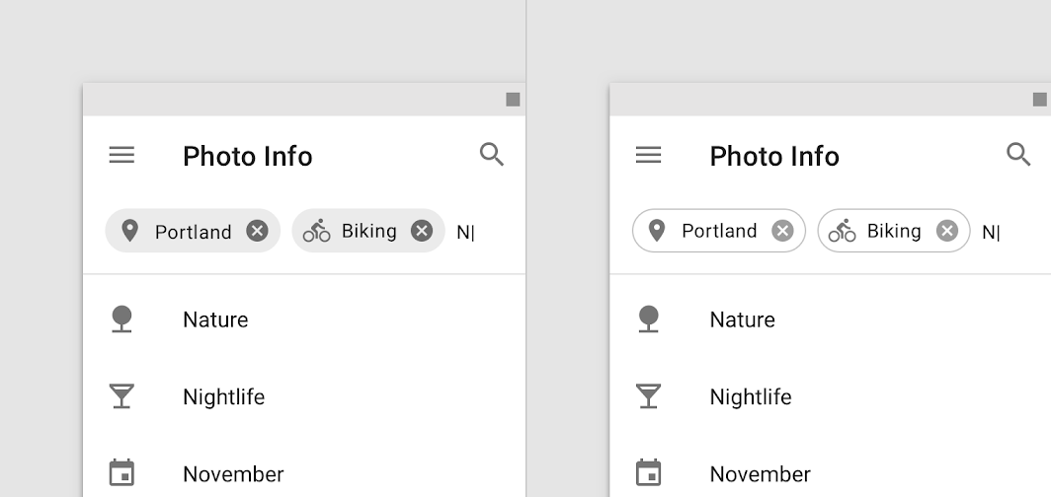

Type 2: **Choice chips**  
In sets that contain at least two options, choice chips represent a single selection.

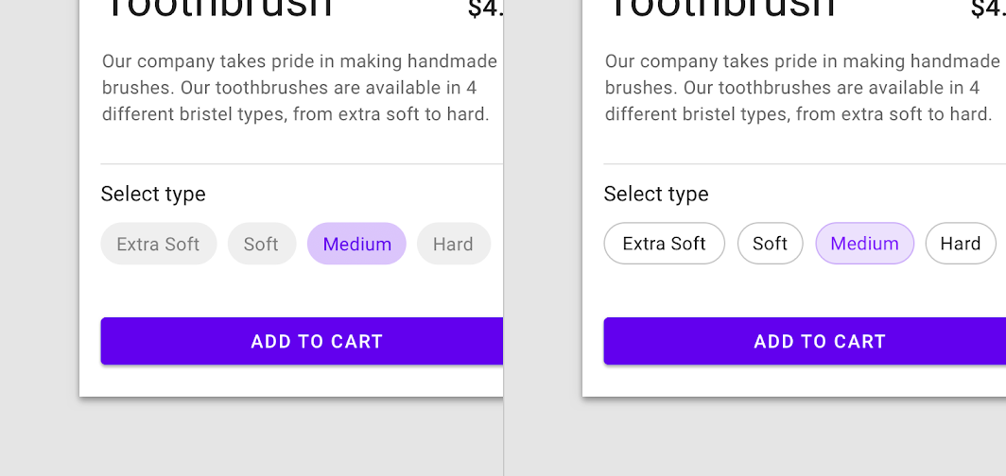

Type 3: **Filter chips**  
Filter chips represent filters for a collection.

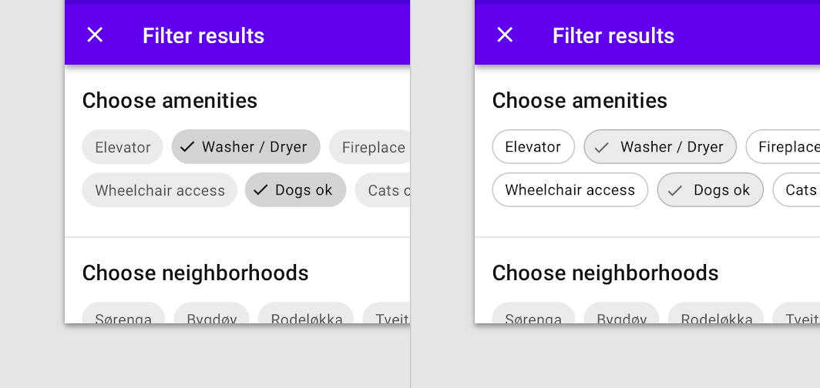

Type 4: **Action chips**  
Action chips trigger actions related to primary content.

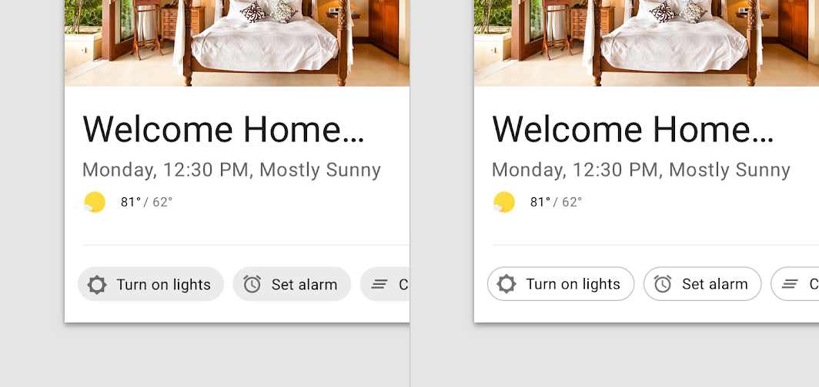

## Anatomy

**1. Container**Chip containers hold all chip elements, and their size is determined by those elements. A container can also be defined by a stroke.

**2. Thumbnail [optional]**Thumbnails identify entities (like individuals) by displaying an avatar, logo, or icon.

**3. Text**Chip text can be an entity name, description, tag, action, or conversational.

**4. Remove icon [optional]**Input chips can include a Remove icon.

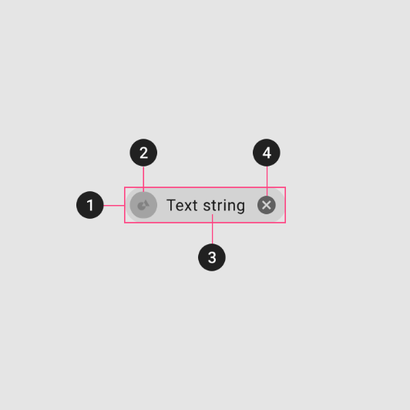

# Data Tables

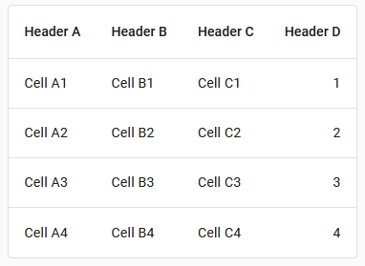

## Usage

Data tables display information in a grid-like format of rows and columns. They organize information in a way that’s easy to scan so that users can look for patterns and develop insights from data.

Data tables can contain:

* Interactive components (such as chips, buttons, or menus)
* Non-interactive elements (such as badges)
* Tools to query and manipulate data

## Principles

#### Organized

Information should be organized in a meaningful way, such as hierarchy or alphabetization.

#### Interactive

Data tables should allow user interaction so that a data display is customizable and interactive.

#### Intuitive

Data tables should be easy to use, with a logical structure that makes content easy to understand.

## Types

No Types

## Anatomy

1. Header row  
   2. Rows  
   3. Pagination  
   4. Row checkbox  
   5. Sort button  
   6. Container

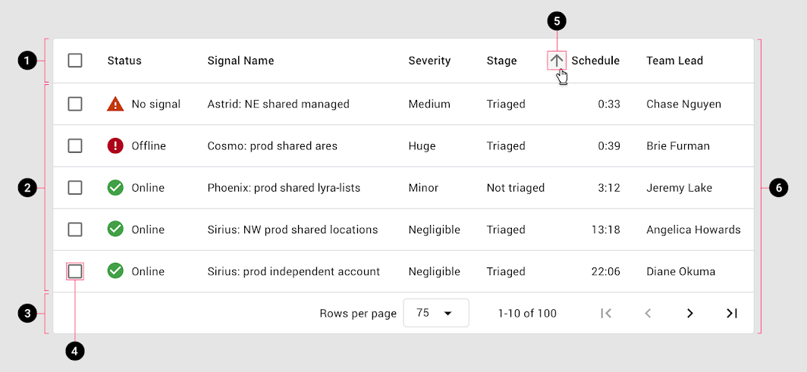

# Dialogs

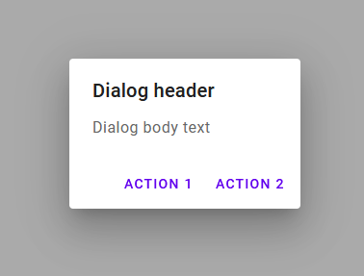

## Usage

A dialog is a type of modal window that appears in front of app content to provide critical information or ask for a decision. Dialogs disable all app functionality when they appear, and remain on screen until confirmed, dismissed, or a required action has been taken.

Dialogs are purposefully interruptive, so they should be used sparingly.

## Principles

*Focused*

Dialogs focus user attention to ensure their content is addressed.

*Direct*

Dialogs should be direct in communicating information and dedicated to completing a task.

*Helpful*

Dialogs should appear in response to a user task or an action, with relevant or contextual information.

## Types

We have 4 different types of dialogs.

Type 1: Alert Dialog

Alert dialogs interrupt users with urgent information, details, or actions.

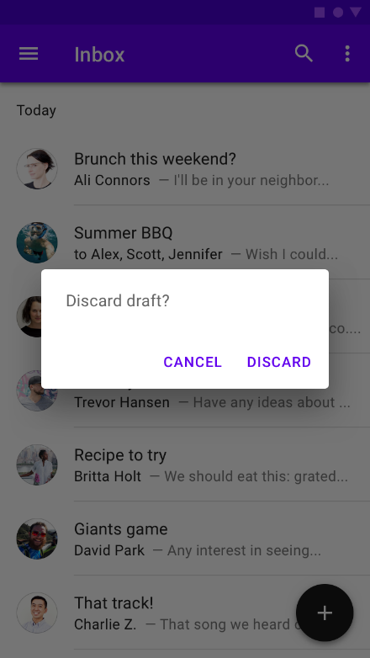

#### Simple dialog

Simple dialogs display a list of items that take immediate effect when selected.

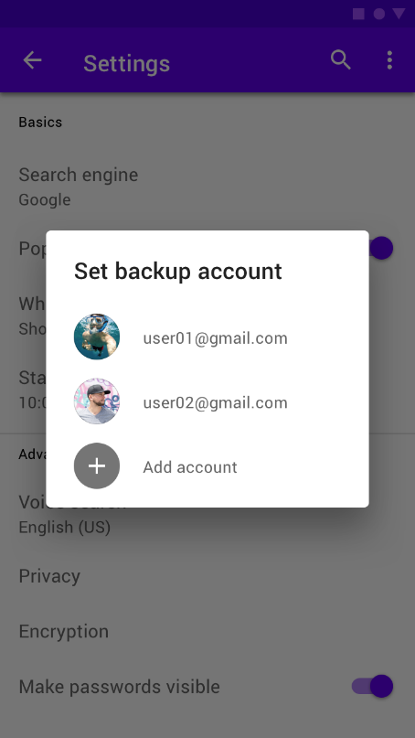

#### Confirmation dialog

Confirmation dialogs require users to confirm a choice before the dialog is dismissed.

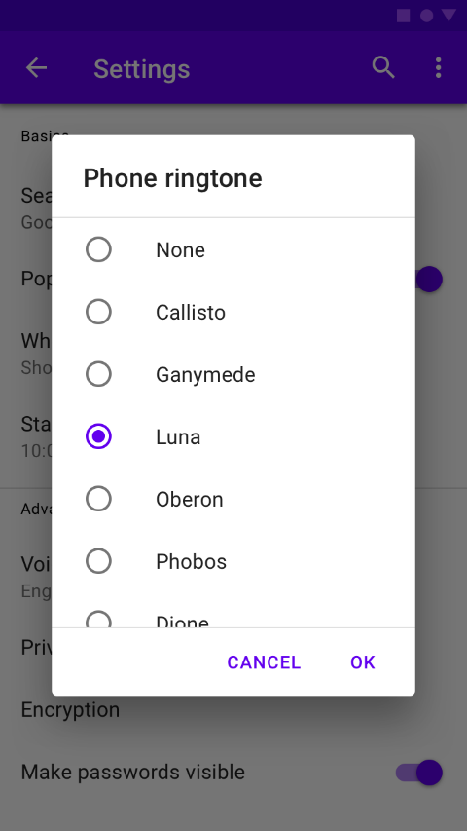

#### Full-screen dialog

Full-screen dialogs fill the entire screen, containing actions that require a series of tasks to complete.

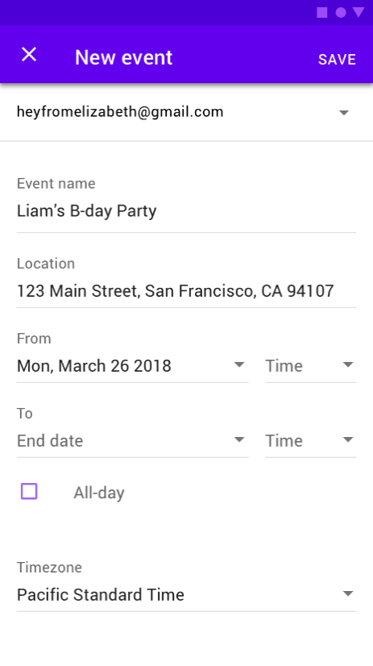

## Anatomy

1. Container
2. Title (optional)
3. Supporting text
4. Buttons
5. Scrim

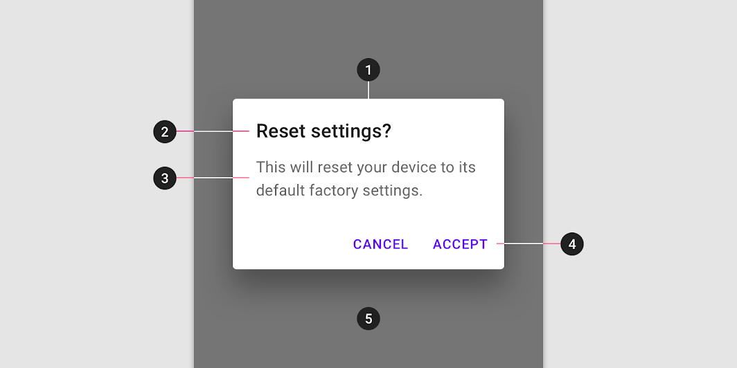

# Image Lists

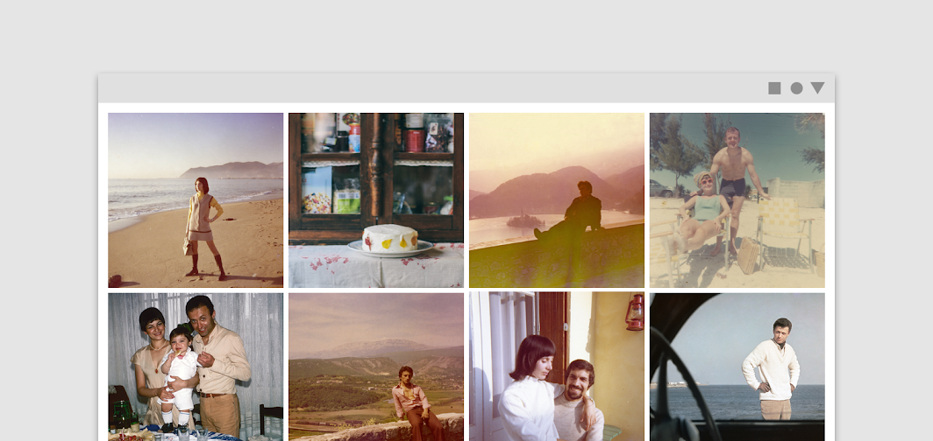

## Usage

Image lists represent a collection of items in a repeated pattern. They help improve the visual comprehension of the content they hold.

## Principles

#### Visual

Image lists allow users to scan content based on images.

#### Comparable

Image lists allow users to easily compare items within a collection.

#### Integrated

Image lists are responsively integrated with the surrounding content and layout.

## Types

Type 1: **Standard image lists** are best for items of equal importance. They have a uniform container size, ratio, and padding.

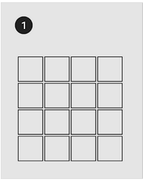

Type 2: **Quilted image lists** emphasize certain items over others in a collection. They create hierarchy using varied container sizes and ratios.

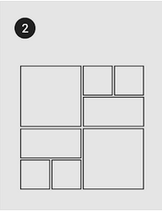

Type 3: **Woven image lists** facilitate the browsing of peer content. They display content in containers of varying ratios to create a rhythmic layout.

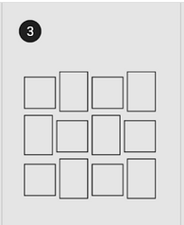

Type 4: **Masonry image lists** facilitate the browsing of uncropped peer content. Container heights are sized based on the image size.

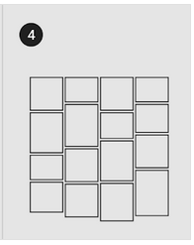

## Anatomy

1. **Image container**  
   The image container displays an image list item’s image or illustration.  
     
   **2. Text labels (optional)**  
   Text labels display one line of text related to an image list item.  
     
   **3. Actionable iconography (optional)**  
   Actionable iconography can represent related actions.  
     
   **4. Text protection (optional)**  
   Text protection is a semi-opaque scrim placed in front of imagery to keep text above it legible.  
     
   **5. Image list item**  
   Image list items represent individual items in an image list.

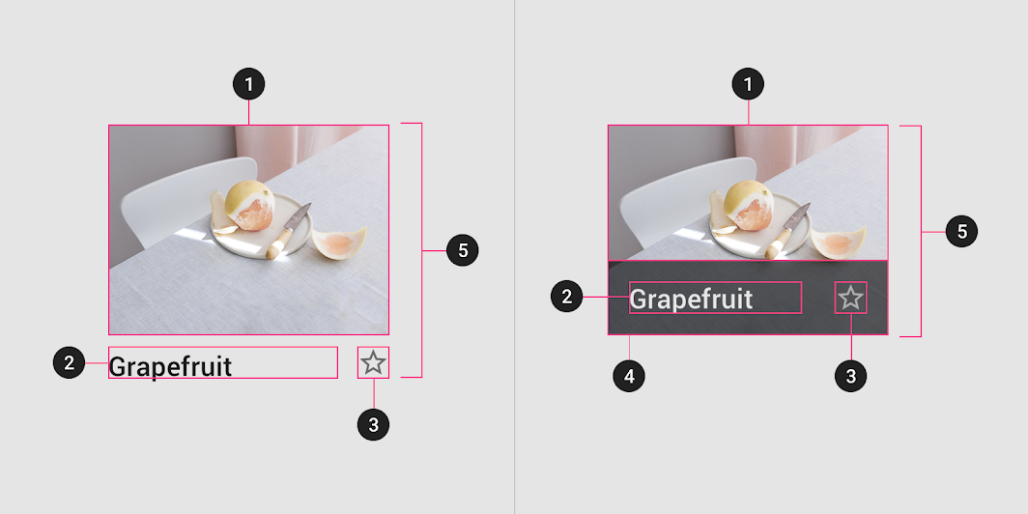

# Lists

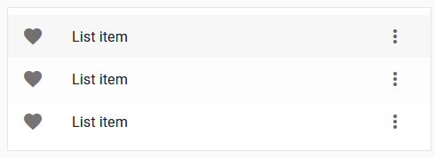

## Usage

Lists are a continuous group of text or images. They are composed of items containing primary and supplemental actions, which are represented by icons and text.

## Principles

#### Logical

Lists should be sorted in logical ways that make content easy to scan, such as alphabetical, numerical, chronological, or by user preference.

#### Actionable

Lists present content in a way that makes it easy to identify a specific item in a collection and act on it.

#### Consistent

Lists should present icons, text, and actions in a consistent format.

## Types

**Type 1: Single-line list**   
Single-line list items contain a maximum of one line of text.

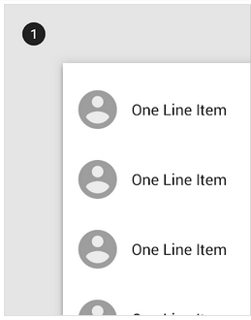  
  
**Type 2: Two-line list**   
Two-line list items contain a maximum of two lines of text.

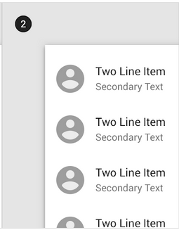  
  
**Type 3: Three-line list**   
Three-line list items contains a maximum of three lines of text.

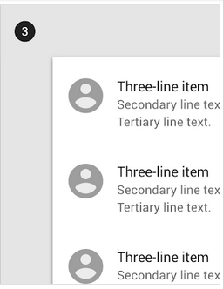

## Anatomy

1. List  
   2. Row  
   3. List item content

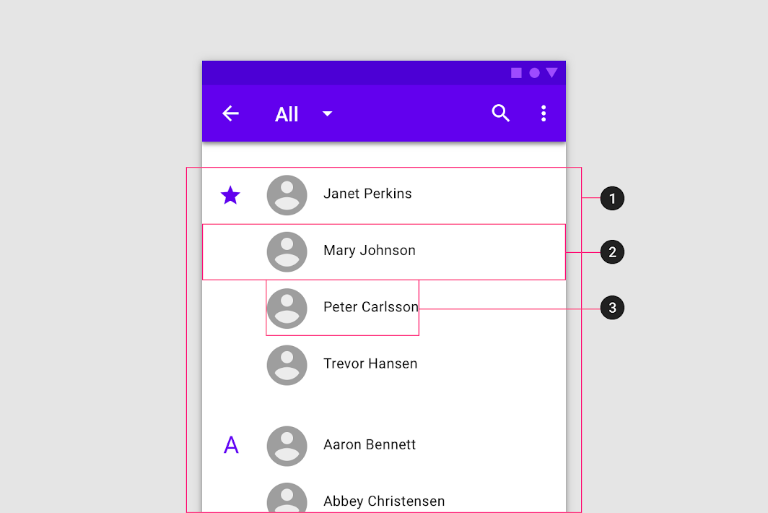

# Menus

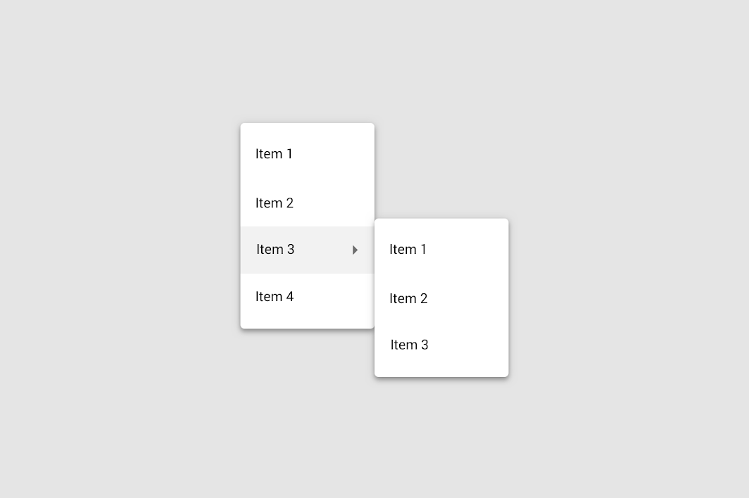

## Usage

A menu displays a list of choices on a temporary surface. They appear when users interact with a button, action, or other control.

## Principles

#### Nimble

Menus should be easy to open, close, and interact with.

#### Contextual

Menu content should be suited to user needs.

#### Scannable

Menu items should be easy to scan.

## Types

Type 1: **Dropdown menus**  
Dropdown menus display a list of options, triggered by an icon, button, or action. Their placement varies based on the element that opens them.

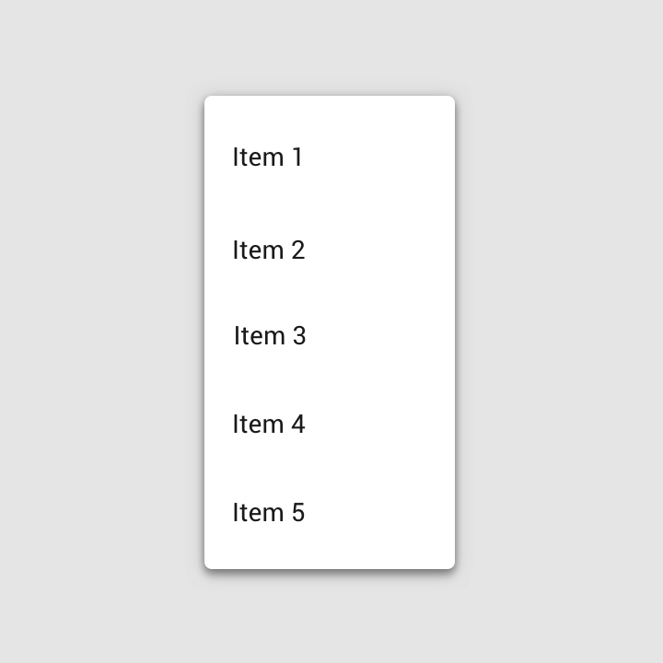

Type 2: **Exposed dropdown menus**  
Exposed dropdown menus display the currently selected menu item above the list of options. Some variations can accept user-entered input.

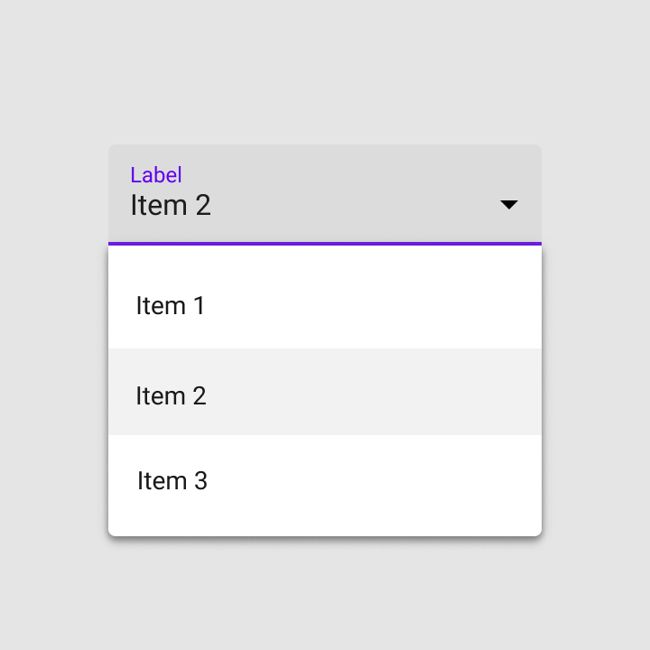

## Anatomy

### Text list

1. Container
2. Text
3. Divider

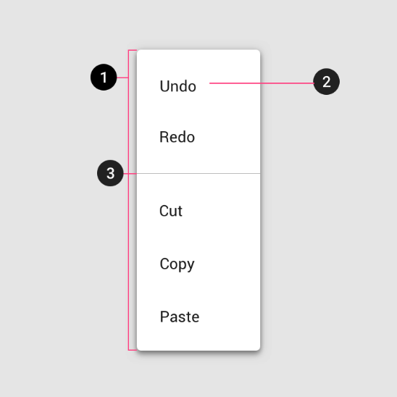

### Text and icon list

1. Container
2. Leading icon
3. Text
4. Divider

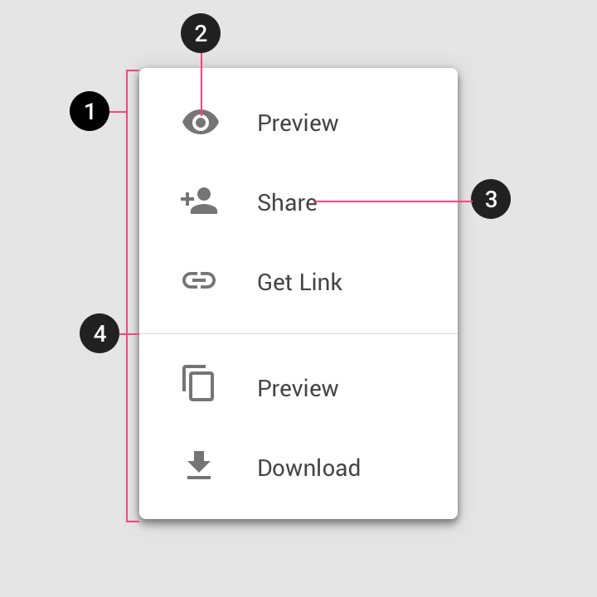

### Text, icon, and keyboard command list

1. Container
2. Leading icon
3. Text
4. Divider
5. Command
6. Cascading menu indicator

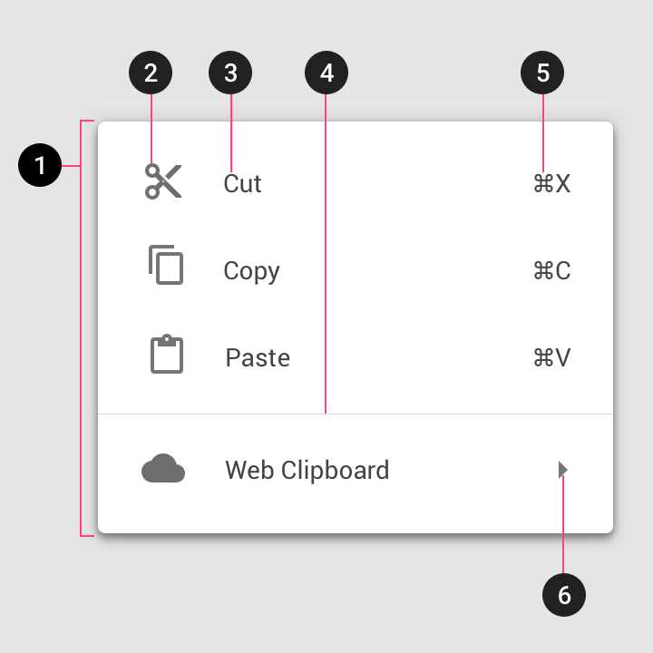

### Text with selection state list

1. Selection state

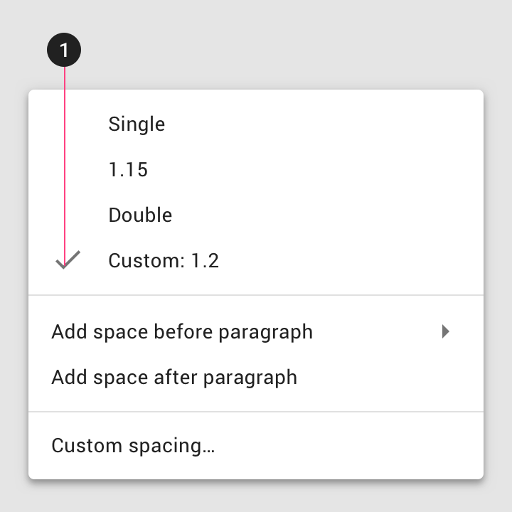

# Nagivation drawer

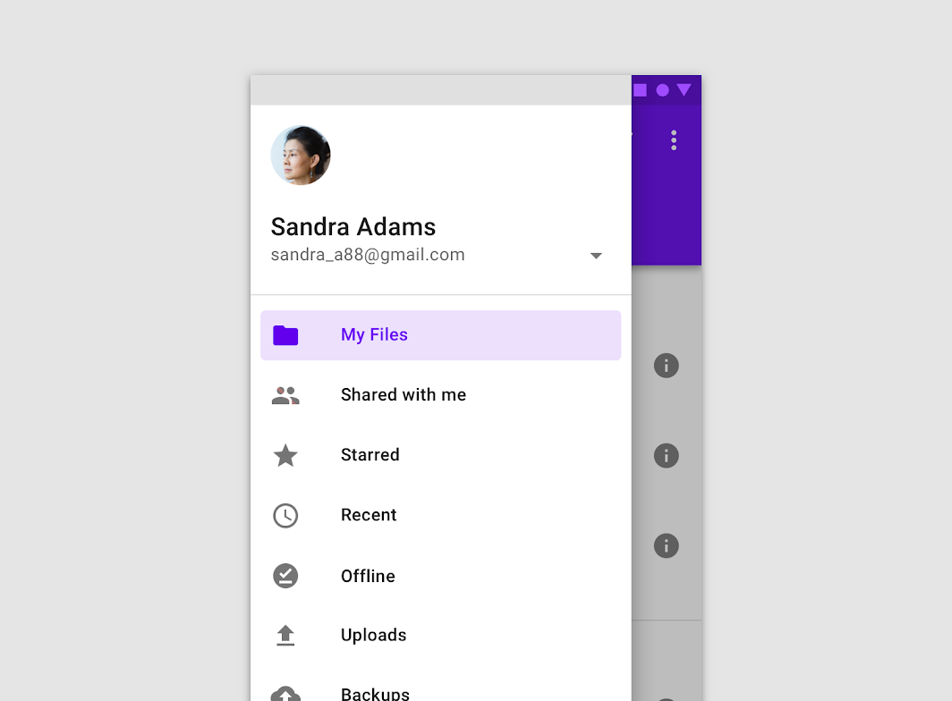

## Usage

Navigation drawers provide access to destinations and app functionality, such as switching accounts. They can either be permanently on-screen or controlled by a navigation menu icon.

Navigation drawers are recommended for:

* Apps with five or more top-level destinations
* Apps with two or more levels of navigation hierarchy
* Quick navigation between unrelated destinations

## Principles

#### Identifiable

The placement and list-style content of navigation drawers clearly identify them as navigation.

#### Organized

Navigation drawers order destinations according to user importance, with frequent destinations first and related ones grouped together.

#### Contextual

Navigation drawers can be shown or hidden to accommodate different app layouts.

## Types

Type 1: **Standard drawer**  
Standard navigation drawers allow users to simultaneously access drawer destinations and app content. They are often co-planar with app content and affect the screen’s layout grid.  
  
Standard drawers can be permanently visible or opened and closed by tapping a navigation menu icon. They can be used on tablet and desktop only. On mobile, modal drawers are used instead.

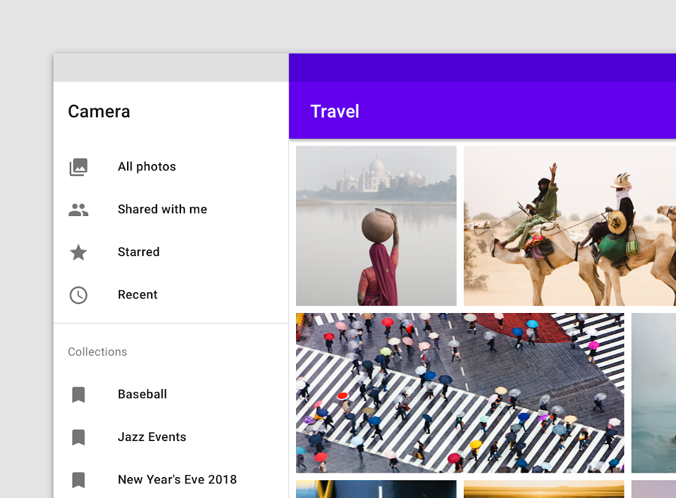

Type 2: **Modal drawer**  
Modal navigation drawers use a scrim to block interaction with the rest of an app’s content. They are elevated above most app elements and don’t affect the screen’s layout grid.  
  
They are primarily for use on mobile, where screen space is limited. They can be replaced by standard drawers on tablet and desktop.

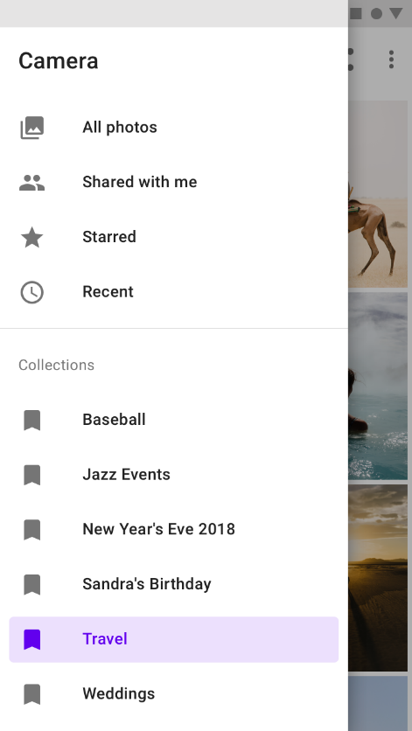

Type 3: **Bottom drawer**  
Bottom navigation drawers are a specialized type of modal drawer for use with a bottom app bar.  
  
For increased reachability from the bottom app bar’s menu icon, they open from the bottom of the screen rather than the side.

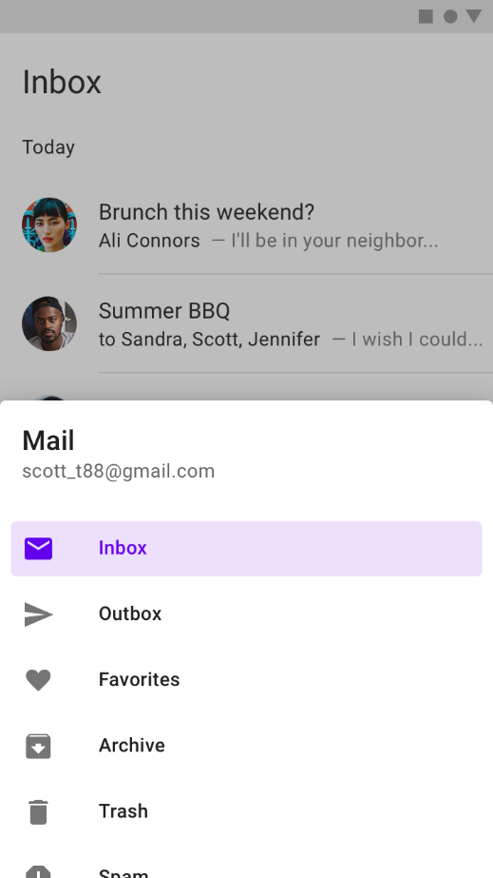

## Anatomy

1. Container  
2. Header (optional)  
3. Divider (optional)  
4. Active text overlay  
5. Active text  
6. Inactive text  
7. Subtitle  
8. Scrim (modal only)

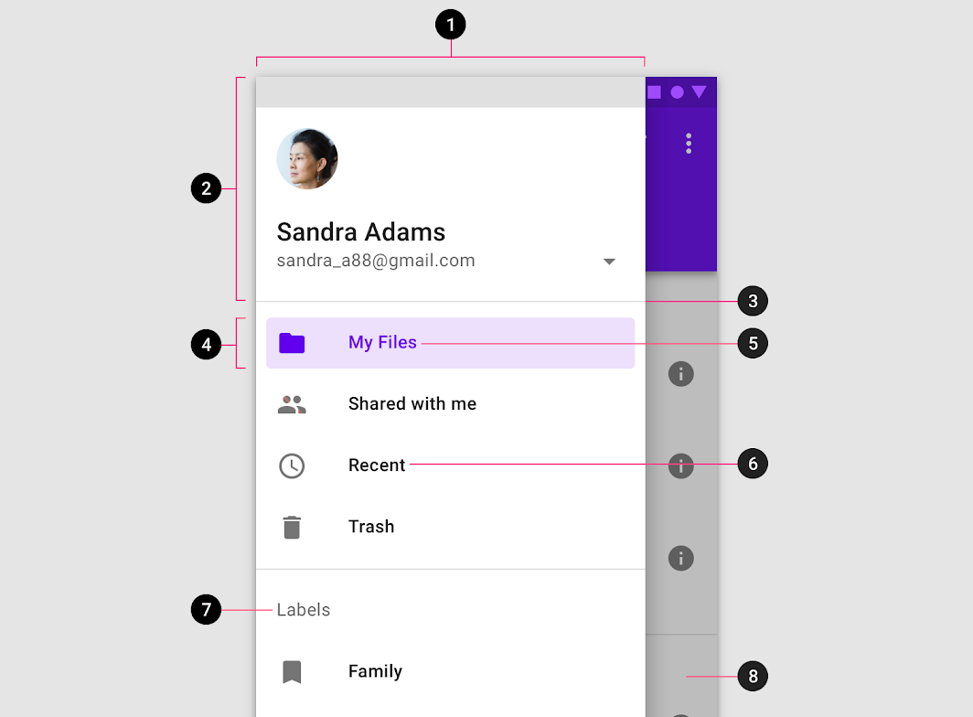

# Progress Indicators

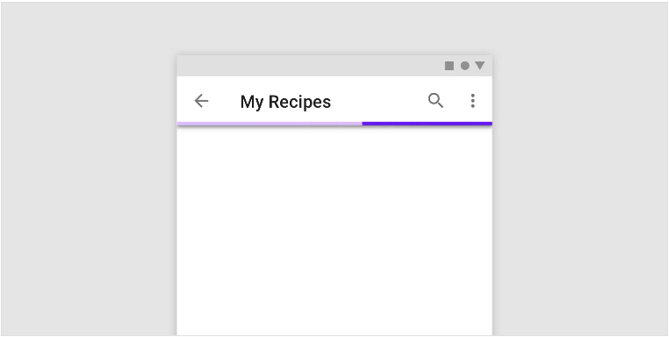

## Usage

Progress indicators inform users about the status of ongoing processes, such as loading an app, submitting a form, or saving updates. They communicate an app’s state and indicate available actions, such as whether users can navigate away from the current screen.

## Principles

#### Informative

Progress indicators look and animate in ways that reflect the status of a process. They are never simply decorative.

#### Animated

Progress indicators use animation to capture attention and inform users of an activity’s progress.

#### Consistent

Progress indicators should be applied to all instances of a process (such as loading) in a consistent format (linear or circular).

## Types

#### Linear and circular

Material Design offers two visually distinct types of progress indicators: linear and circular progress indicators. Only one type should represent each kind of activity in an app. For example, if a refresh action displays a circular indicator on one screen, that same action shouldn’t use a linear indicator elsewhere in the app.

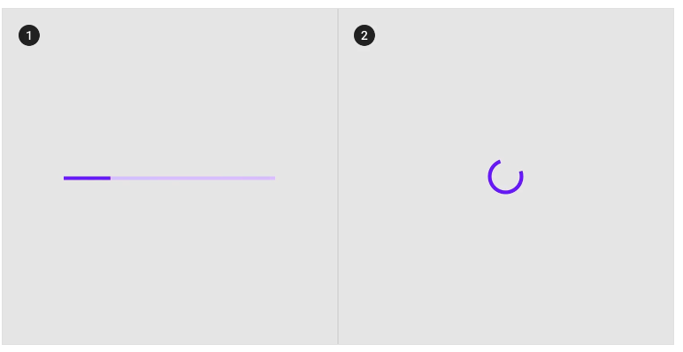

## Anatomy

**1. Track**  
The track is a fixed width rule, with set boundaries for the indicator to travel along.

**2. Indicator**  
The indicator animates along the length of the track.

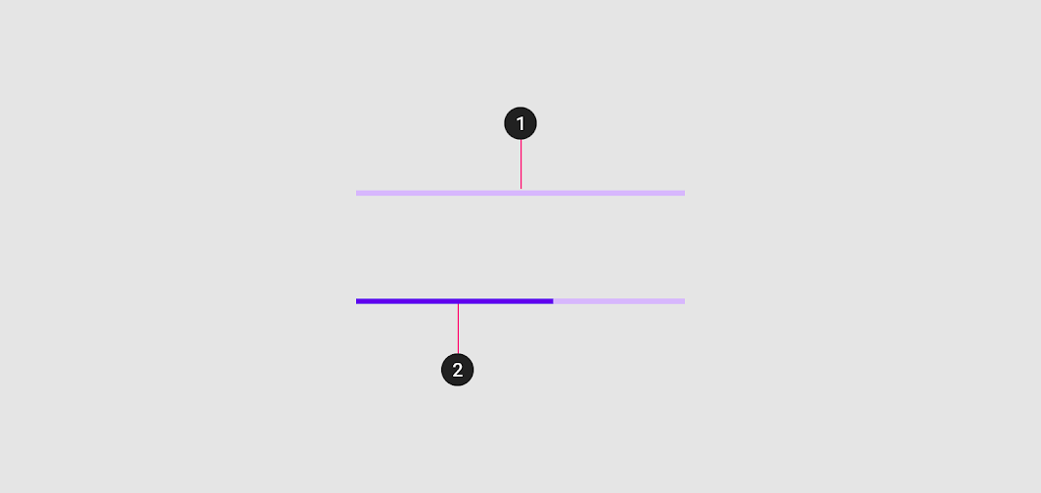

# Radio Buttons

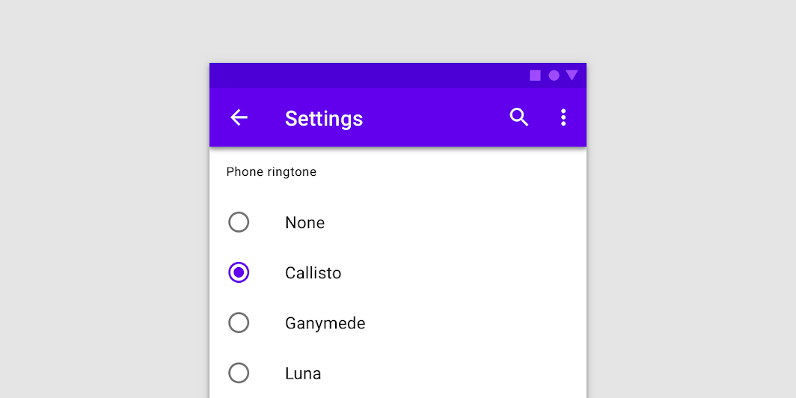

## Usage

Use radio buttons to:

* Select a single option from a list
* Expose all available options

If available options can be collapsed, consider using a dropdown menu instead, as it uses less space.

## Principles

#### Familiar

Radio buttons have been in user interfaces for a long time and should be used as expected.

#### Scannable

It should be visible at a glance if a radio button has been selected, and selected items should be more visually prominent than unselected items.

#### Efficient

Radio buttons make it easy to compare available options.

## Types

Same types as checkbox.

## Anatomy

Same anatomy as checkbox.

# Sliders

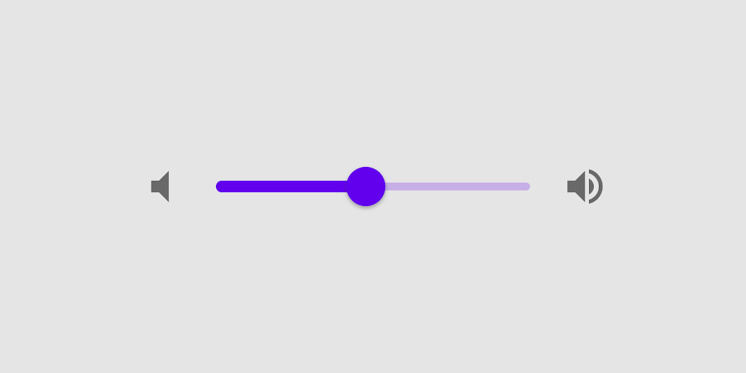

## Usage

Sliders allow users to view and select a value (or range) from the range along a bar. They’re ideal for adjusting settings such as volume and brightness, or for applying image filters.

Sliders can use icons on both ends of the bar to represent a numeric or relative scale. The range of values or the nature of the values, such as volume change, can be communicated with icons.

## Principles

#### Adjustable

Sliders should be used for making selections from a range of values.

#### Immediate

When interacting with a slider, changes should be reflected back to a user immediately.

#### Accessible

Sliders should present the full range of choices that are available to a user.

## Types

Type 1: Continuous sliders

Continuous sliders allow users to set and select a value along a subjective range.

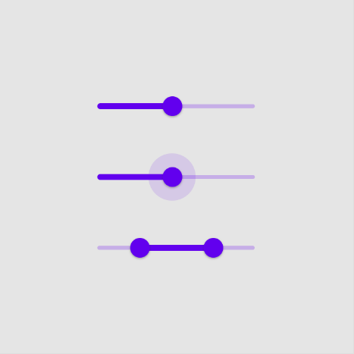

Type 2: Discrete sliders

Discrete sliders can be adjusted to a specific value by referencing its value indicator.

Allowed selections may be organized and indicated with tick marks that a slider thumb will snap to.

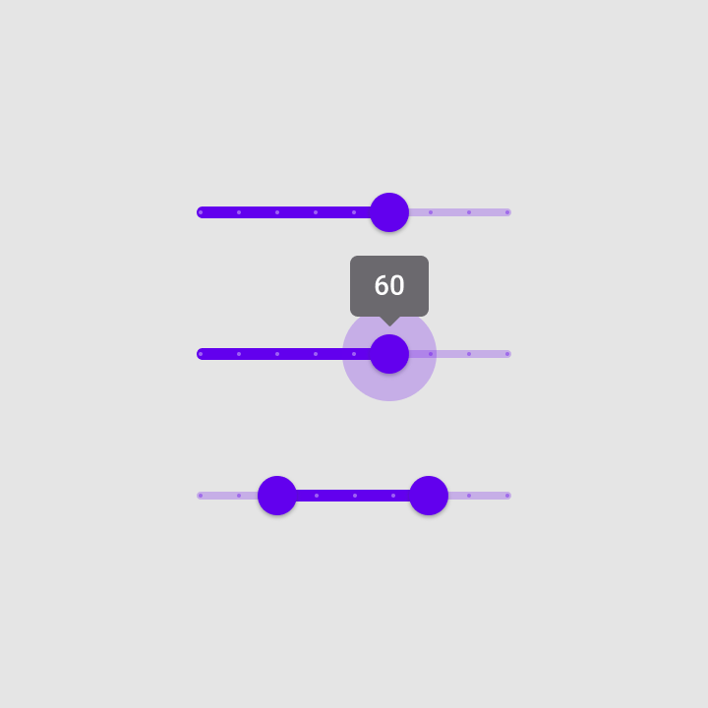

## Anatomy

**1. Track**The track shows the range that is available for a user to select from. For left-to-right (LTR) languages, the smallest value appears on the far left end of the track and the largest value is on the far right. For right-to-left (RTL) languages this orientation is reversed.

**2. Thumb**The thumb is a position indicator that can be moved along the track, displaying the selected value of its position.

**3. Value label (optional)**A value label displays the specific numeric value that corresponds with the thumb’s placement.

**4. Tick mark (optional)**Tick marks along a track represent predetermined values that the user can move the slider to.

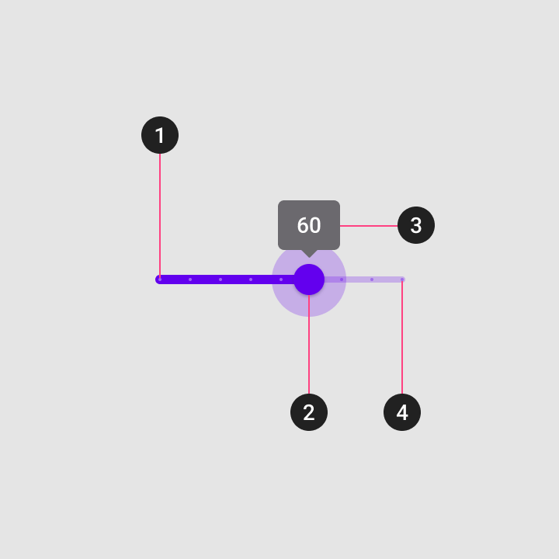

# Snackbars

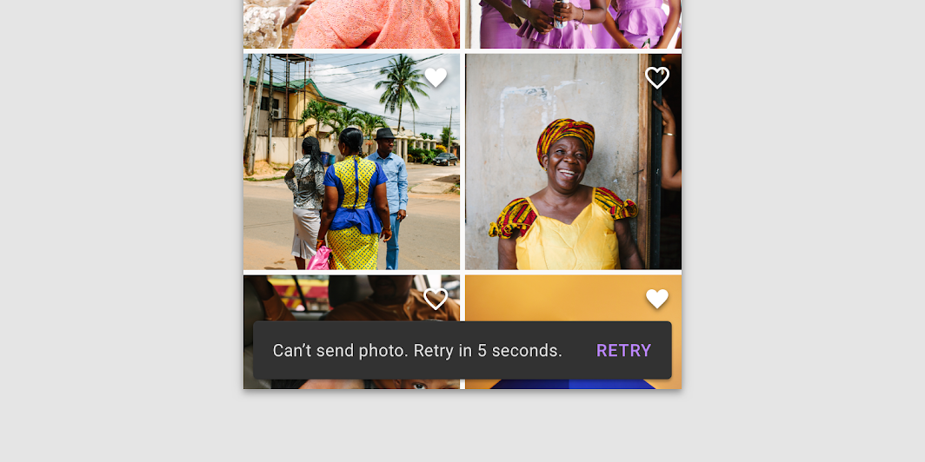

## Usage

Snackbars inform users of a process that an app has performed or will perform. They appear temporarily, towards the bottom of the screen. They shouldn’t interrupt the user experience, and they don’t require user input to disappear.

## Principles

#### Informational

Snackbars provide updates on an app’s processes.

#### Temporary

Snackbars appear temporarily, and disappear on their own without requiring user input to be dismissed.

#### Contextual

Snackbars are placed in the most suitable area of the UI.

## Types

No Types.

## Anatomy

1. Text label
2. Container
3. Action (optional)

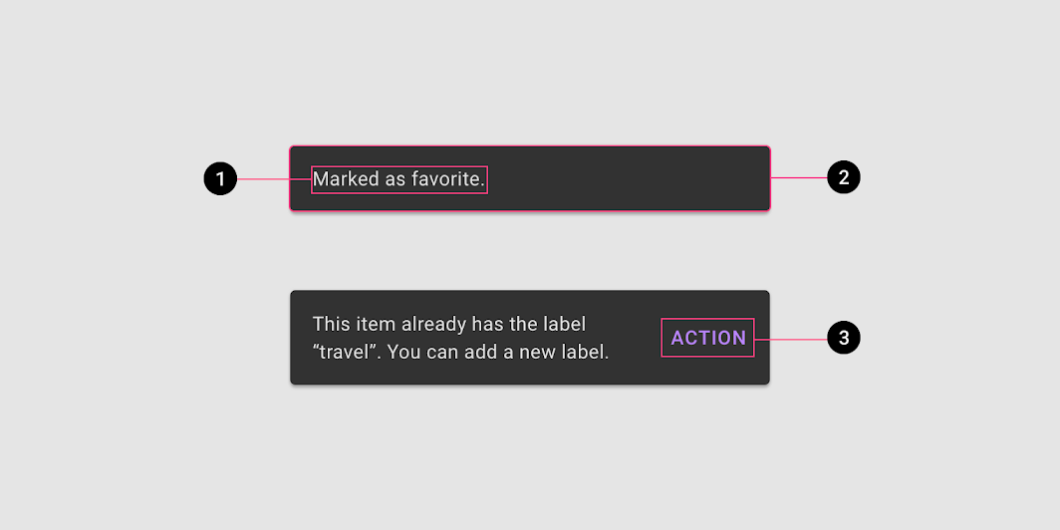

# Switches

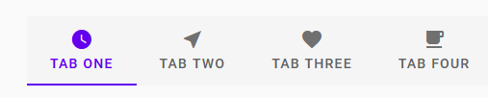

## Usage

Switches are the preferred way to adjust settings on mobile.

Use switches to:

* Toggle a single item on or off, on mobile and tablet
* Immediately activate or deactivate something

## Principles

#### Familiar

Switches have been in user interfaces for a long time and should be used as expected.

#### Scannable

It should be visible at a glance if a switch has been selected, and selected items should be more visually prominent than unselected items.

#### Efficient

Switches make it easy to compare available options.

## Types

Same types as CheckBox

## Anatomy

Same anatomy as CheckBox

# Tabs



## Usage

Tabs organize and allow navigation between groups of content that are related and at the same level of hierarchy.

## Principles

#### Scalable

As tabs can horizontally scroll, a UI can have as many tabs as needed.

#### Informative

Tabs organize content into categories to help users easily find different types of information.

#### Peers

Tabs are displayed next to each other as peers, in categories of equal importance.

## Types

Type 1: Fixed tabs

Fixed tabs display all tabs on one screen, with each tab at a fixed width. The width of each tab is determined by dividing the number of tabs by the screen width. They don’t scroll to reveal more tabs; the visible tab set represents the only tabs available.

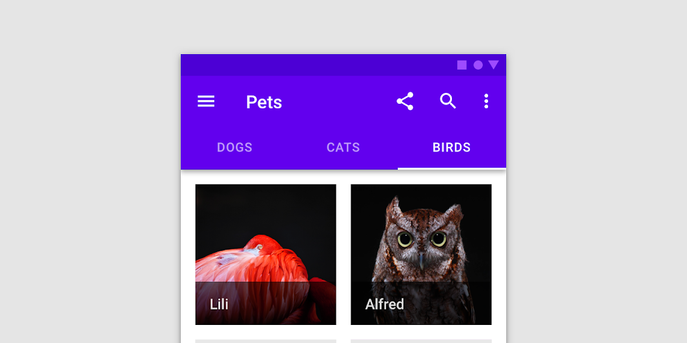

Type 2: Scrollable tabs

Scrollable tabs are displayed without fixed widths. They are scrollable, such that some tabs will remain off-screen until scrolled

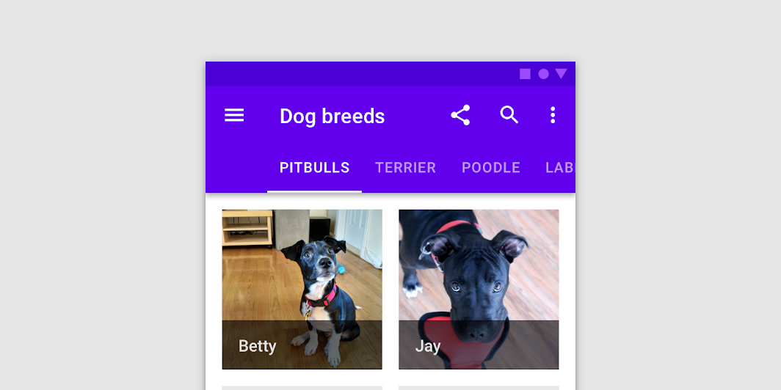

## Anatomy

1.Container  
2.Active icon (Optional if there’s a label)  
3. Active text label (Optional if there’s an icon)  
4.Active tab indicator  
5.Inactive icon (Optional if there’s a label)  
6.Inactive text label (Optional if there’s an icon)  
7.Tab item

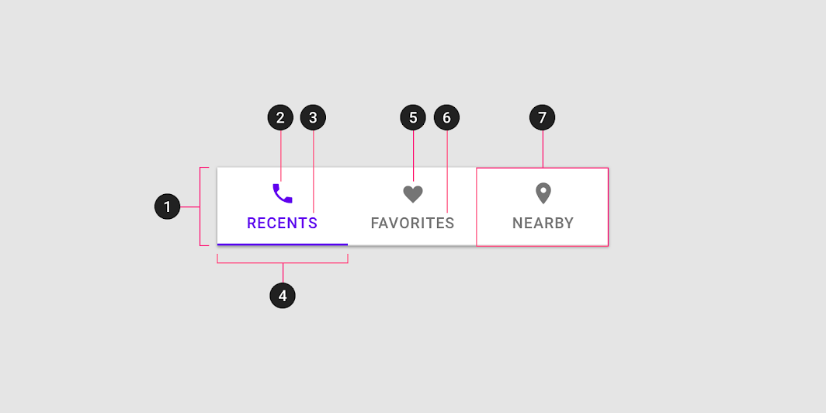

# Text fields

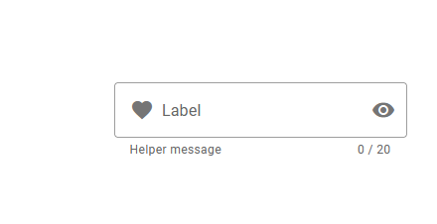

## Usage

Text fields allow users to enter text into a UI. They typically appear in forms and dialogs.

## Principles

#### Discoverable

Text fields should stand out and indicate that users can input information.

#### Clear

Text field states should be clearly differentiated from one another.

#### Efficient

Text fields should make it easy to understand the requested information and to address any errors.

## Types

Type 1. Filled text fields

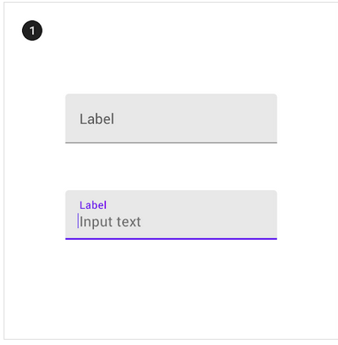

Type 2: Outlined text fields

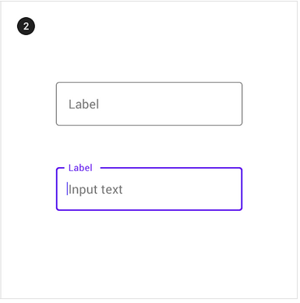

## Anatomy

1. Container  
   2. Leading icon (optional)  
   3. Label text  
   4. Input text  
   5. Trailing icon (optional)  
   6. Activation indicator  
   7. Helper text (optional)

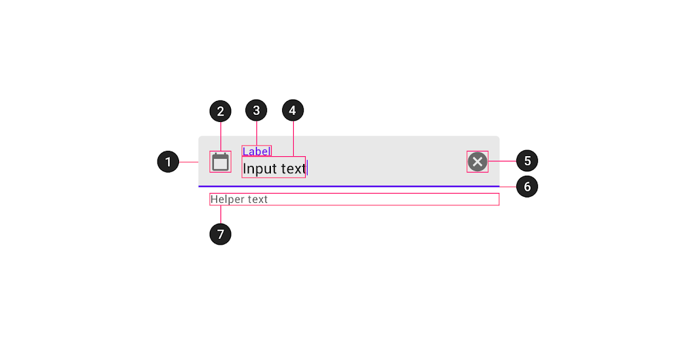

# Tooltips

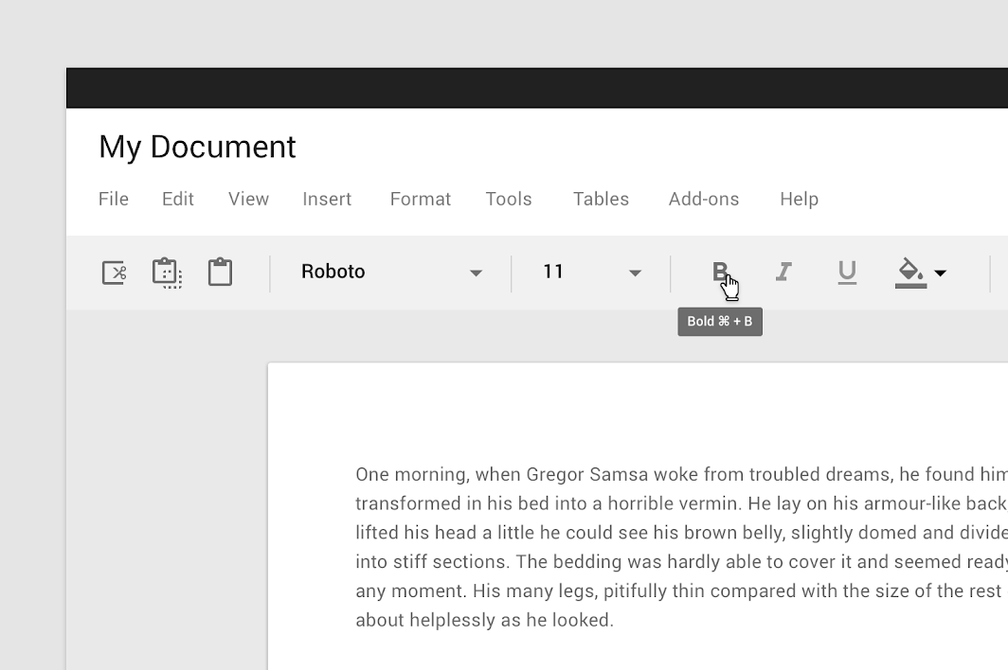

## Usage

When activated, tooltips display a text label identifying an element, such as a description of its function.

## Principles

#### Transient

Tooltips appear on hover, focus, or touch, and disappear after a short duration.

#### Paired

Tooltips are always paired nearby the element with which they are associated.

#### Succinct

Tooltips only include short, descriptive text.

## Types

No Types

## Anatomy

No anatomy.